September 2019 Flyer V.3
When heavy rainfall hit a narrow culvert that was already undercut and leaking, the result was a road washout and 48 hours of traffic problems on Highway 19A where the south branch of McNaughton Creek crossed under it. That was in November 2017, and that incident led to its complete replacement now.

The culvert that washed out was three times too narrow for the stream it was carrying, and was an old closed-bottom style like thousands of others under BC’s highways which will be creating the same problems as they too rust out, become undercut, or fail under the weight of traffic. Sean Wong, senior biologist for BC’s Ministry of Transportation told Fanny Bay Salmonid Enhancement Society members all that and more when he toured some of us over the culvert’s former location. A new and improved design will among other things, last for 75 years, carry the creek on its own streambed under the road, and provide necessary habitat for fish passage.

Fanny Bay Salmonid Enhancement Society members already knew that McNaughton Creek deserves a break. Because FBSES members have long been rescuing wild fry from creeks that dry in warm weather, we can show you the numbers. In the 22 years up to 2018, 51,977 coho fry were salvaged, and this year, 829, just from McNaughton. Of course the stream produces far more coho along its 5km, (3.2 mile) run, the problem area is from 19A north to tidewater.

And that brings us to the ‘fisheries window’ and big parts of one of the other million commandments we all live by, the Fisheries Act. Especially subsection 35(1) which prohibits HADD; harmful alteration, disruption and destruction of fish habitat. It’s complicated and Wong told FBSES that complying with it has meant some innovative thinking on the part of MOTengineers. The fisheries window on Vancouver Island runs from June 15 to September 15 for coho streams and you get it done then or not at all.

Now to the road closure; Sean Wong and Angus Taschuk, a excavating contractor with a sterling reputation for his enhancement skills with a crawler tractor, will be working six day weeks to keep the environmental part on track, while Mainroad North Island and contractor Dig Dug of Courtenay build, fill, compact and pave, and then get out of the way.

The new McNaughton culvert will be 11 meters (40 feet) wide and 3.5 meters (10 feet tall) and is a galvanized steel arch assembled on site that will rest on concrete footings only along its edges, leaving the center open over the old natural stream bed that was still in place under the road.

The road closure will always be too long and too inconvenient for many, but we have all seen the results of not caring enough for the world we live in. Fanny Bay Salmonid Enhancement Society’s volunteers are doing their part and we appreciate improvements that make things better for salmon. And we have to drive the long way around too.

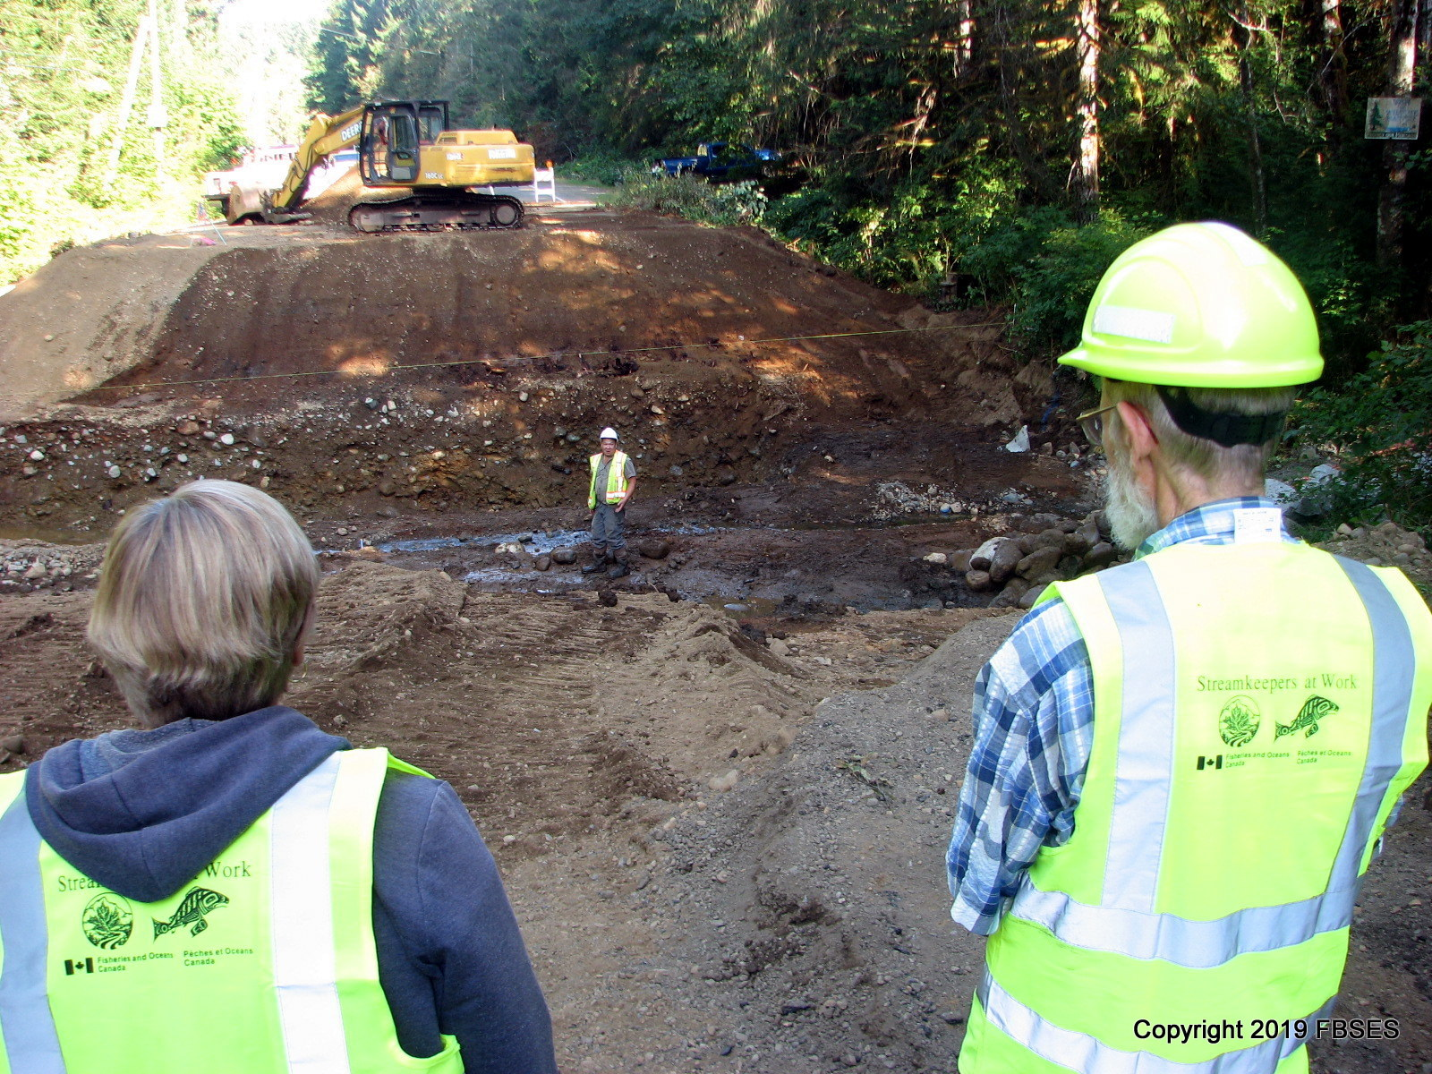

Picture caption; This is where it all goes. Judy Ackinclose, left, and John Todd, right, view the site with Sean Wong, senior biologist, MOT, in the center.
www.fbses.ca is our website. Work party days are Wednesday and Saturday mornings.

